**Summer Camp with English 2016**

**Plan of Work**

**Hrodivska School**

**Krasnoarmiysk Region**

**Teacher of English**

**Horbunova**

**Svitlana Oleksandrivna**

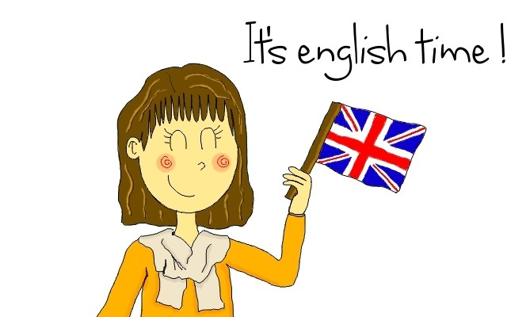

**Time of work: 9.00-12.00 (4-6 forms)**

**Topic: Discover Britain**

|  |  |  |  |  |  |
| --- | --- | --- | --- | --- | --- |
| **Time/days** | **Monday** | **Tuesday** | **Wednesday** | **Thursday** | **Friday** |
|  | Welcome to England | Welcome to England | Welcome to Scotland | Welcome to Scotland | Welcome to Wales |
| 9.00-9.20 | Funny gymnastics | Funny gymnastics | Funny gymnastics | Funny gymnastics | Funny gymnastics |
| 9.20-10.00 | Watching a film “This is England” | A role-play “I am in London” | Project “Walking on the map” | Watching a cartoon “Music in Scotland” | Watching a film “Wales’ Castles” |
| 10.00-10.40 | Project “let’s make a map of England” | Project “discovering streets in London” | A magic trip to the lake Lochness | A discussing club “I like Scotland because…” | A quest time  “ let’s travel around Wales” |
| 10.40-11.20 | A game “let’s dream»: If I were in London… | Watching a film “Baker Street” | A competition in drawing “Scottish wonders” | Making a project  “ Meet Scotland” | A game “ The best translator” |
| 11.20-11.40 | A game “Tricks From the Box” | A game “Match words” | A game “snowball” | A game “Chairs” | A game “Tricks from the box” |
| 11.40-12.00 | A game “quis-quis trade” | Words battle “this is England” | A game “match words” | A game “ Match words” | A game with English cards |

|  |  |  |  |  |  |
| --- | --- | --- | --- | --- | --- |
| **Time/days** | **Monday** | **Tuesday** | **Wednesday** | **Thursday** | **Friday** |
|  | Welcome to Wales | Welcome to Northern Ireland | Welcome to Northern Ireland | British stereotypes | A fair of British holidays |
| 9.00-9.20 | Funny gymnastics | Funny gymnastics | Funny gymnastics | Funny gymnastics | Funny gymnastics |
| 9.20-10.00 | Project “In the Welsh kitchen” | Watching a film “A trip to Belfast” | Watching a film “Giant Causeway” | It’s tea-time! (a round table) | A concert “Welcome to Britain” |
| 10.00-10.40 | A visit to the Harlech Castle in Wales | A role-play “How to get to…? | Project “Wonders of Northern Ireland” | Project “What are they, the British? | A fashion show “The best costume” |
| 10.40-11.20 | A competition “the gallery of Wales” | Project “I’d like to visit” | A game with English cards | A game “it never rains on Monday” | A game “ I can do it” |
| 11.20-11.40 | A game with English cards | A game “match words” | A game “snowball” | A game “quis-quis trade” | A project “Discover Britain” |
| 11.40-12.00 | A game “match words” | A game “Tricks From the Box” | A game “catch the Irish” | A project “Discover Britain” | A project “Discover Britain” and saying Good-bye! |