***Ukrainian Culture Time***

***Quiz-show: “Hrodivka is my Motherland”***

Horbunova Svitlana Oleksandrivna

09.04.1984

Hrodivska comprehensive school

Krasnoarmiysk district

Donetsk region

The teacher of English

0993285359

[funn2009@meta.ua](mailto:funn2009@meta.ua)

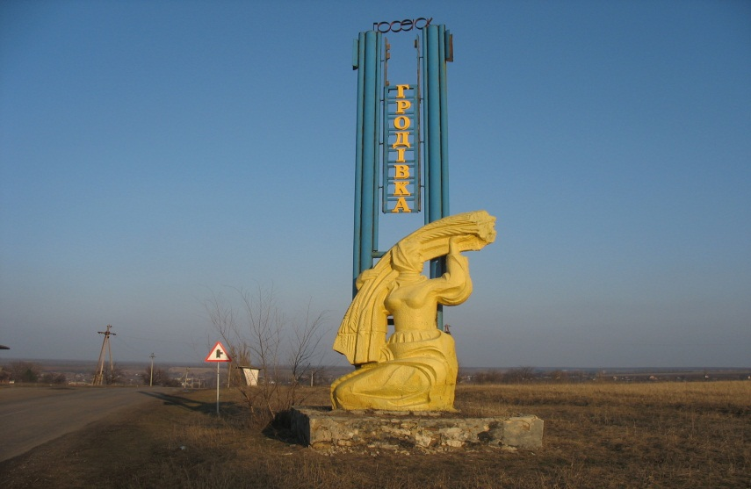

**Theme:** “Hrodivka is my Motherland”

**Aims:**

- To extend pupil’s knowledge about the history and culture of our native village Hrodivka;

* To control the level of knowledge of adjectives in English;
* To develop skills in listening, speaking and reading in English;
* To develop pupil’s erudition and speed of thinking;
* To educate respect to the native village, people, traditions, history and culture.

**Materials:** a computer class, a multimedia board, a computer, a record’s board, two word-puzzles, a magic-box with different things, photos of the village Hrodivka.

**Age:** the 5th and the 6th forms.

**Teacher:** Good morning, dear boys and girls. Welcome to our quiz-show “Travelling”. The topic of our show is “Hrodivka is my Motherland”.

So, let’s start travelling across Hrodivka. Today we have two teams “The Smartest” from the 5th form and “The Fastest” from the 6th form. Let’s greet each other with applause.

(The pupils greet each other)

**Teacher:** dear pupils, today you’ll find out many interesting facts about the history of our native village Hrodivka. You should be attentive, smart and fast. We’ll have 5 different tasks on the topic of our show. At the end the winner will get a nice prize. It’s a book about the origin of Krasnoarmiysk district.

So, our first task is called “Words’ Battle”. One by one you should describe our native villagers with adjectives. The winner is the team with the biggest number of adjectives.Well, we are…

(The answers are: generous, hard-working, strong, brave, kind, hospitable, beautiful, open-hearted, sincere…)

**Teacher:** Well-done! As we can see the people in Hrodivka are very friendly and nice. So, welcome to Hrodivka!

Now it’s time for our second task “Across the history of Hrodivka”. Each team will be given 4 questions with two answers to each one. The winner is of course who gives more right answers.

So, “The Smartest” let’s start from you.

1. Who were the first settlers in Hrodivka?
2. The Polish b) **Zaporizhian Cossacks**
3. What is the name of the river in Hrodivka?
4. **Kazenyi Torets** b) Siverskyi Donets
5. What is the territory of hrodivka?
6. **5388 hr**. b) 7400 hr.
7. What part of Hrodivka was settled first?
8. **“Kholodna Balka”** b) “Krasna Balka”

**Teacher:** Clever you are. And now it’s your turn “the Fastest”.

1. When did Hrodivka first appear?
2. **In 1750**  b) in 1650
3. What was built in Hrodivka in 1936?

a) **school**  b) church

3. How did Hrodivka get its name?

a) from the river Hrod b) **from Mr. Hrodov**

4. Why was “Besalivka” called in this way?

a**) there were poor people, without lard**

b) there were a family of Besaliv

**Teacher:** That’s great! You know the history of Hrodivka perfectly. But I have two extra-questions:

1. When was the first wooden church built?

a) in 1860 b)**in 1793**

2. What is the population of Hrodivka?

a) **about 4000** b) about 3000

**Teacher:** We continue. The third task is “Sightseeing in Hrodivka”. We have 12 pictures from our village. You should name each picture in turn. Let’s start…

( додаток 1)

1. A school
2. A policlinics
3. A monument to Cossacks
4. A kindergarten
5. A Palace of culture
6. A church
7. A sports ground
8. A Bus stop
9. A monument of World War II
10. The village government
11. A sand-pit
12. A monument to starving

**Teacher:** I am proud of you. You know almost all the places in our village. And now look at the blackboard. Here we have a map of Hrodivka. Let’s glue each photo on this map and see how wonderful our village is!

Our fourth task is “Word-puzzle”. Each team has a puzzled proverb. You have to match words in order as fastest as you can. Two points for the winner and one point for the last one.

1. “There is no place like home”
2. “East or West Home is Best”

**Teacher:** That’s great! I think every person must love his Motherland. As for me, a man without motherland is like a man without heart.

Let’s talk about customs and traditions in our village. It’s time for the fifth task “Magic Box”. There are three things for each team in this box. You have to name the holiday according to the thing.

A plate with pancakes (on a picture) – A Pancake Holiday

“pysanka” – Easter

A New Year toy – New Year

A candle – Memory Day of Starving

A valentine – St. Valentine’s Day

A pumpkin – Halloween

**Teacher:** You are great. Almost all the tasks have been finished. The only thing is left…you know, sometimes, dreams help us to live. Today I want to share my dream with you. I dream to see our village happy, healthy, peaceful and wealthy. I wish it were plants, new playgrounds for children, bakery and rich crops here. I have prepared some pictures beforehand and they must be on our map of Hrodivka. So, come up to me one by one and glue these photos on the map saying “I’d like to have…”

(A big hospital, a comfortable playground for children, a chemist’s, a bakery, plants and good roads.)

**Teacher:** We have done a nice plan for the future of our village.

Now, let’s greet the winner of our show. It is a team…

Children, have you enjoyed the show?

Thank you for taking part in this game. I hope, that you will remember lots of interesting facts about Hrodivka. We have a nice village and we should be proud of it. Let’s read the topic of our show together: “Hrodivka is my Motherland!” Welcome to Hrodivka!

Додаток 1

A school

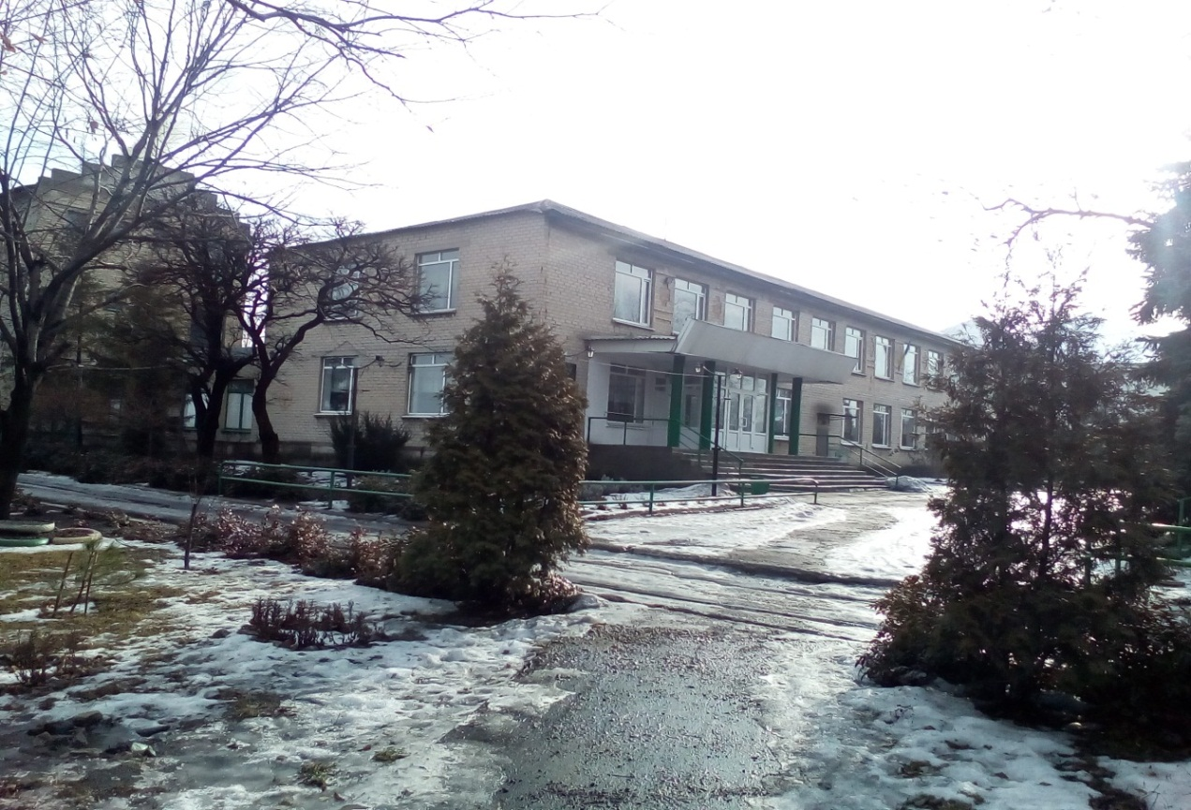

Policlinics

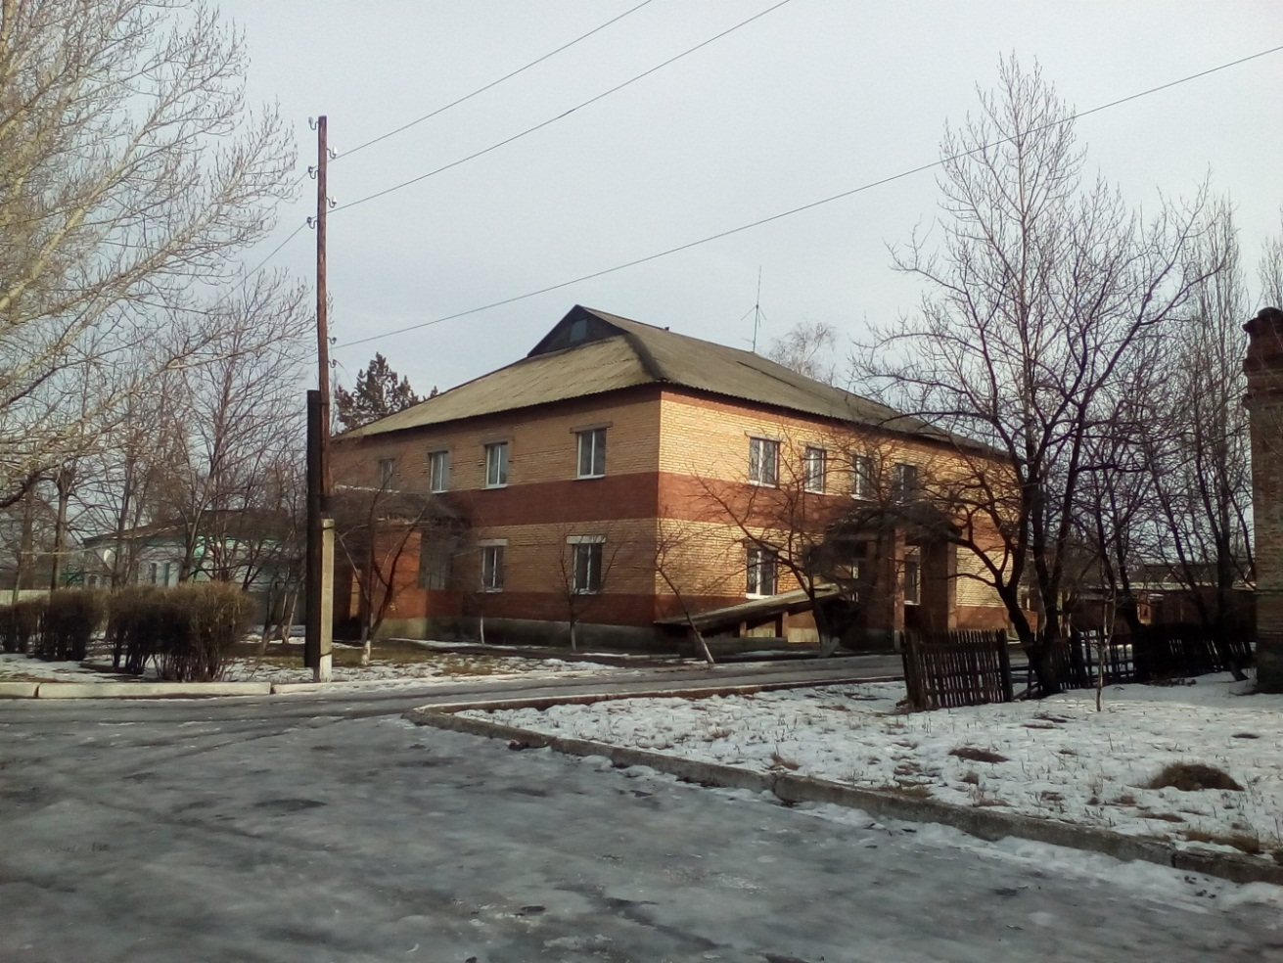

A monument to Cossacks

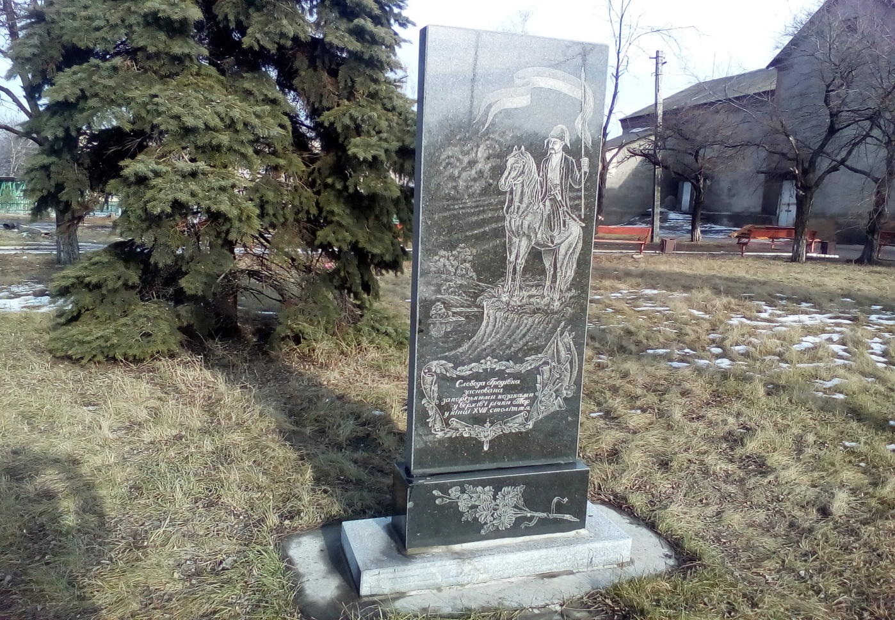

A kindergarten

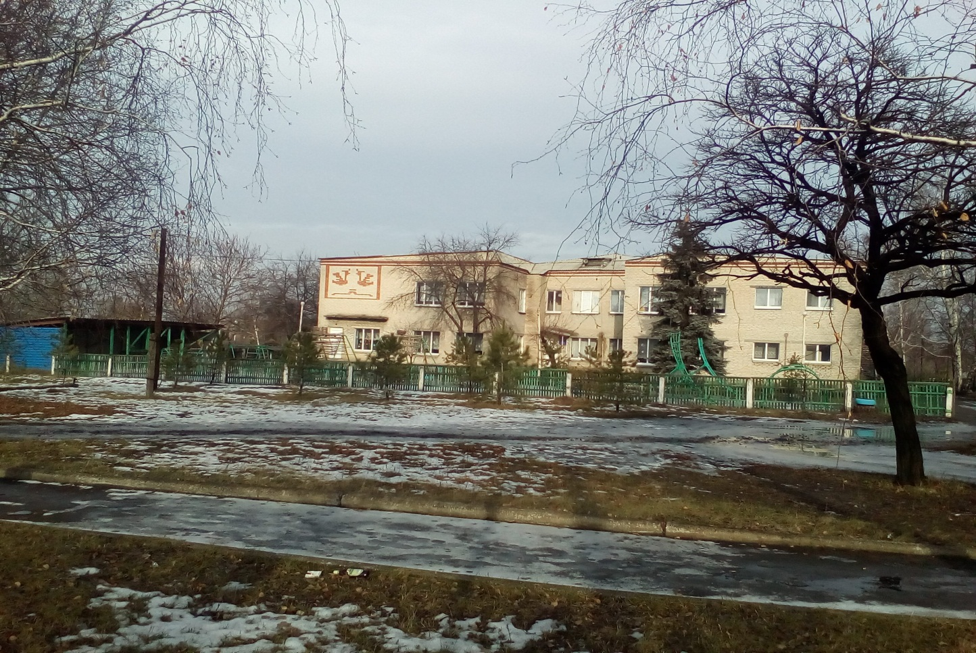

A Palace of culture

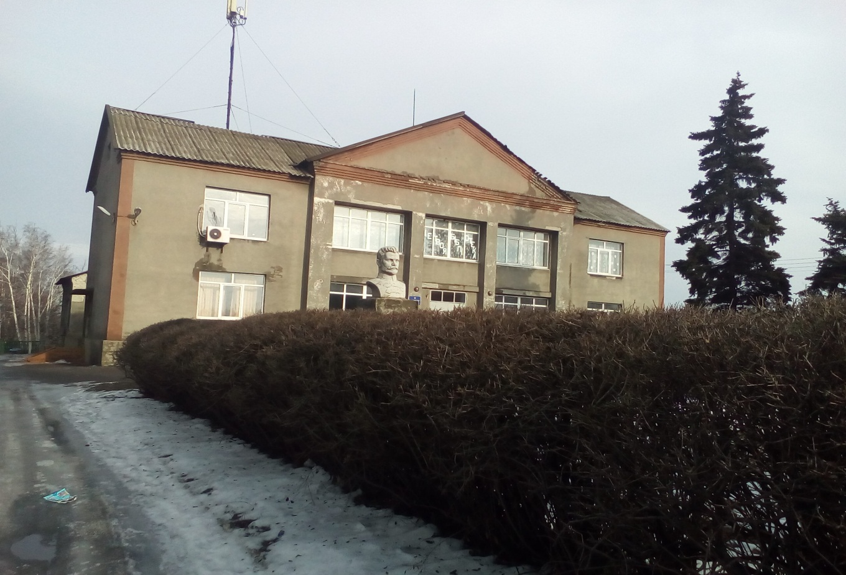

A church

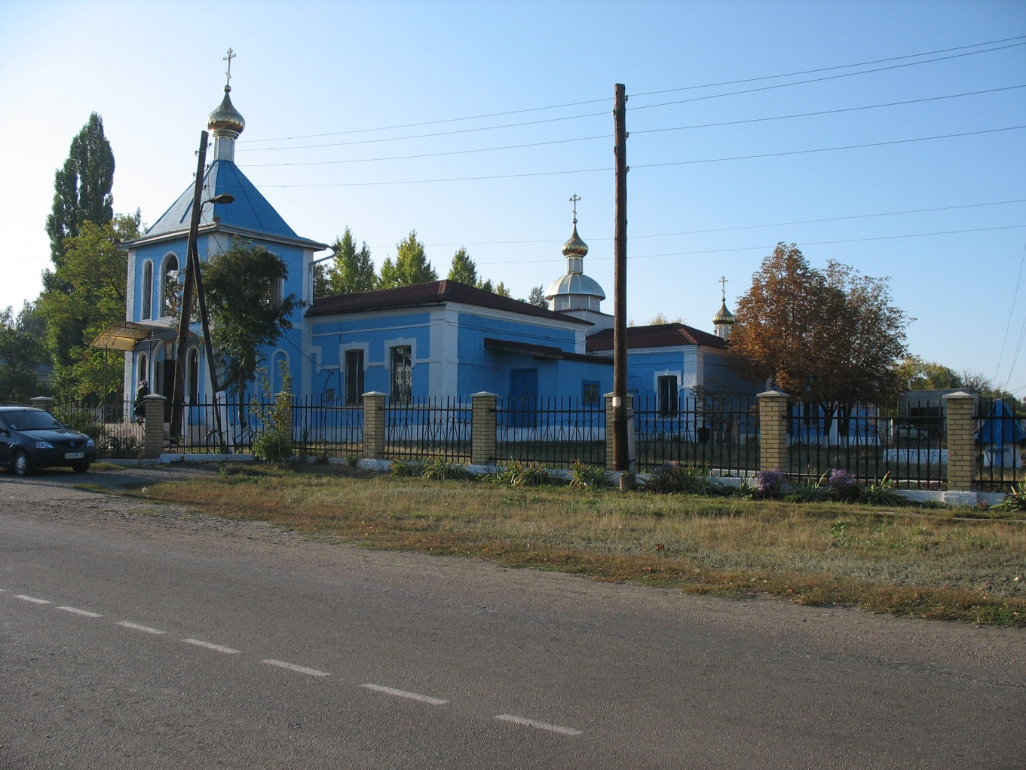

A monument to starving

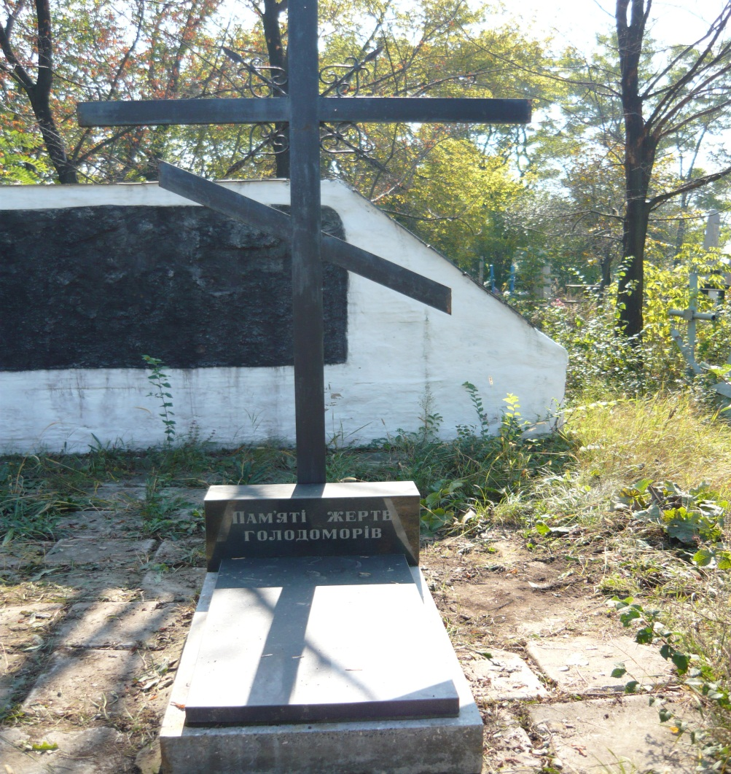

The village government

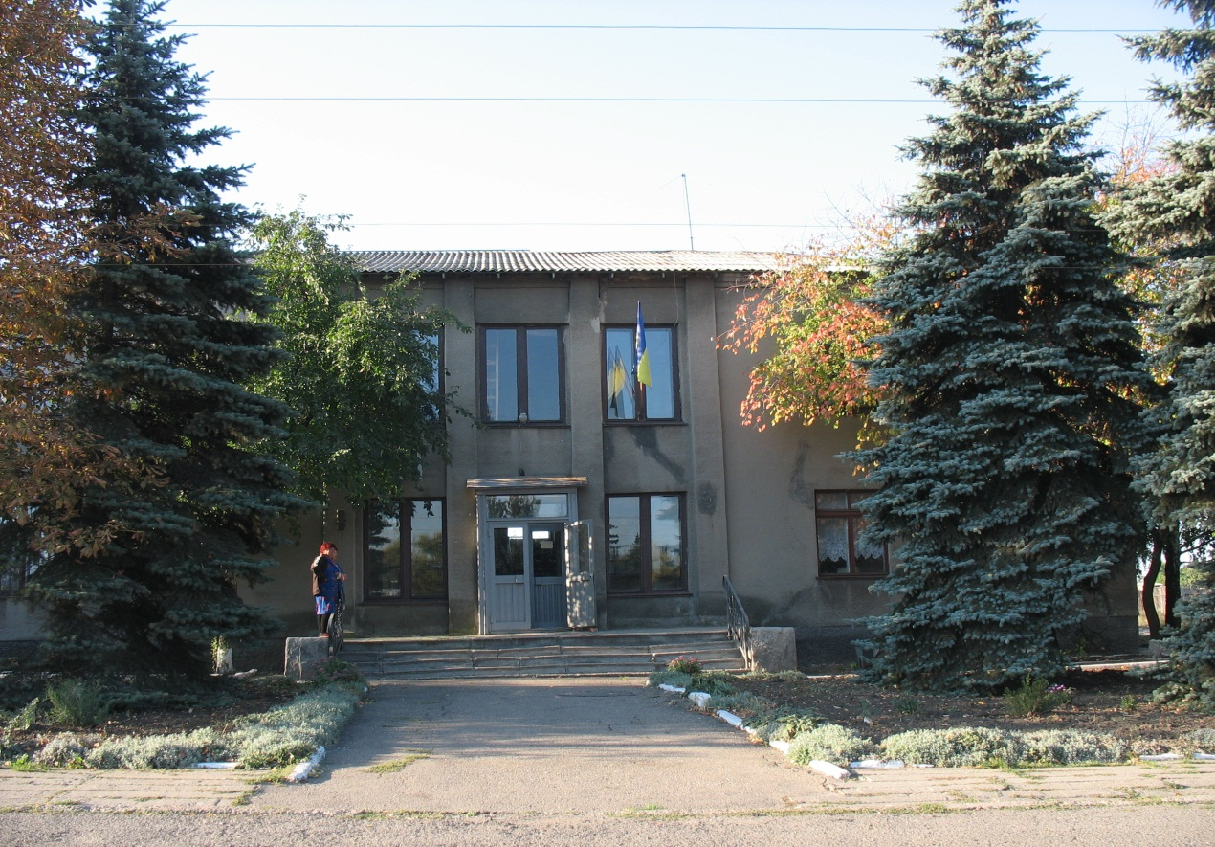

A monument of World War II

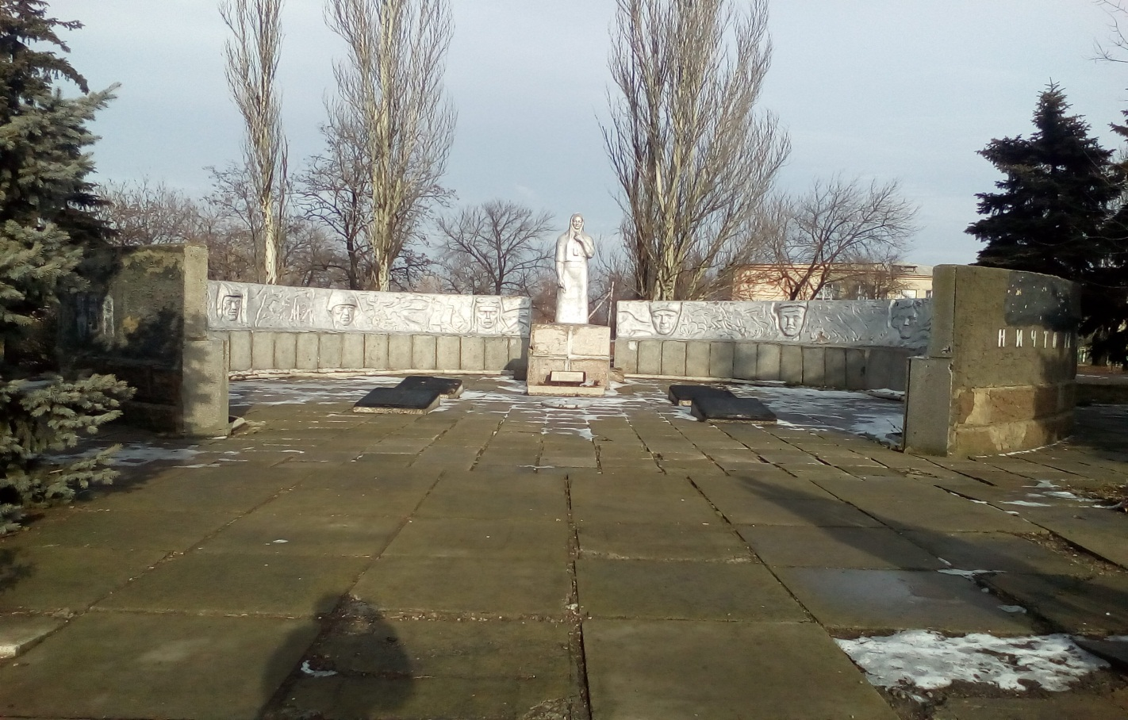

A Bus stop

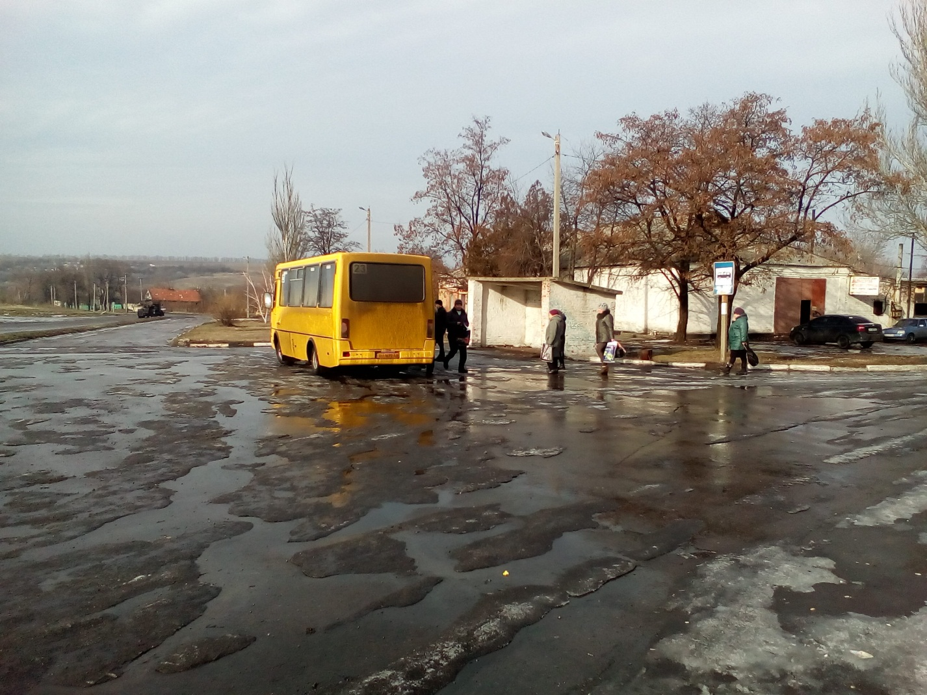

A sports ground

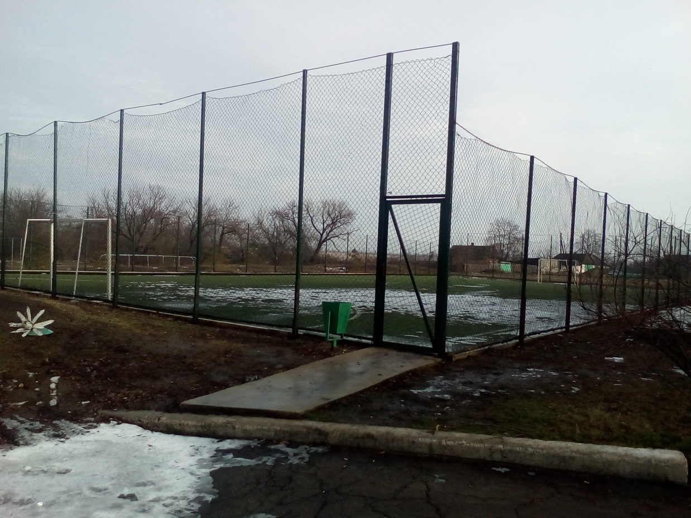

A sand-pit

