**СЦЕНАРІЙ ІГРОВОЇ ПРОГРАМИ**

**ЛІТНЬОГО МОВНОГО ТАБОРУ**

**ГРОДІВСЬКОЇ ЗОШ І-ІІІ СТУПЕНІВ**

**КРАСНОАРМІЙСЬКОГО РАЙОНУ**

**ДОНЕЦЬКОЇ ОБЛАСТІ**

**ЗА ТЕМОЮ «СВІТ КВІТІВ»**

**ВЧИТЕЛЯ АНГЛІЙСЬКОЇ МОВИ**

**ГОРБУНОВОЇ СВІТЛАНИ ОЛЕКСАНДРІВНИ**

**2016**

**The World of Flowers**

**A rose:** Good morning dear boys and girls. Welcome to the World of Flowers. What do you think “Who am I”? Yes, you are right. I am a rose – a queen of the flowers and a symbol of England. Today I will let you go to a wonderful world of flowers.

**A poppy:** Hello, my friends. I am a poppy – a famous Ukrainian flower. I will help you today to have fun and enjoy the time.

**A rose:** Well, let’s start our trip. Children, what are your favourite flowers?

Thank you for your answers. You know so many flowers, but some of them you don’t know in English.

**A poppy:** So, we are ready to help you. Meet some flowers.

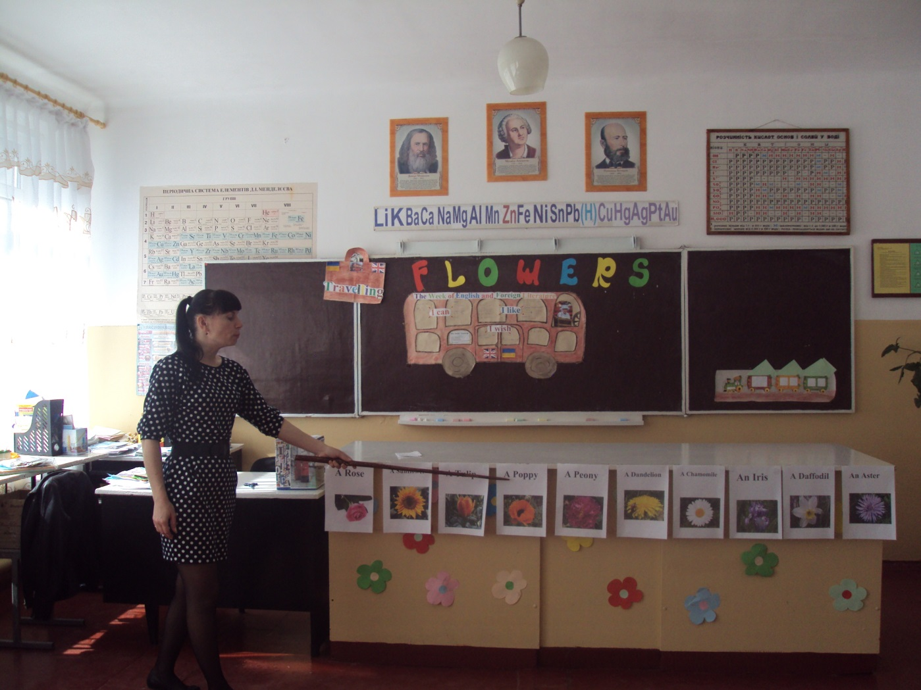

**A rose:** Try to say after me each flower. Well done! I wonder what flowers do you like. Start like this: I like…

**A poppy:** It’s great! You can name these flowers. Let’s check up how you can match a picture of the flower with its name.

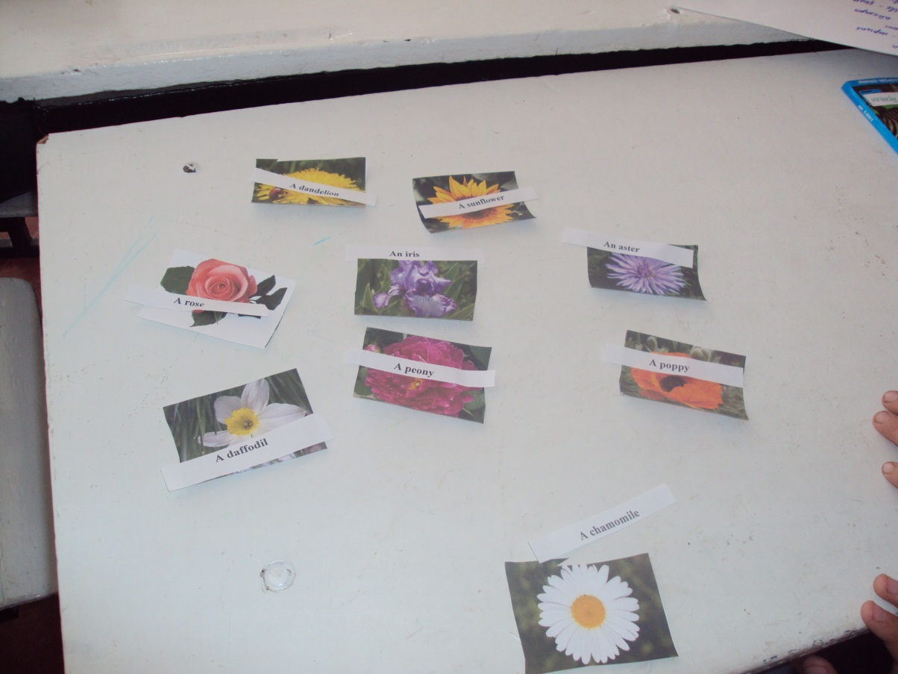

**A rose:** How clever of you! Let’s visit a fair of flowers where they were mixed. Now I give you cards with flowers and try to find the same picture. Start finding your couple.

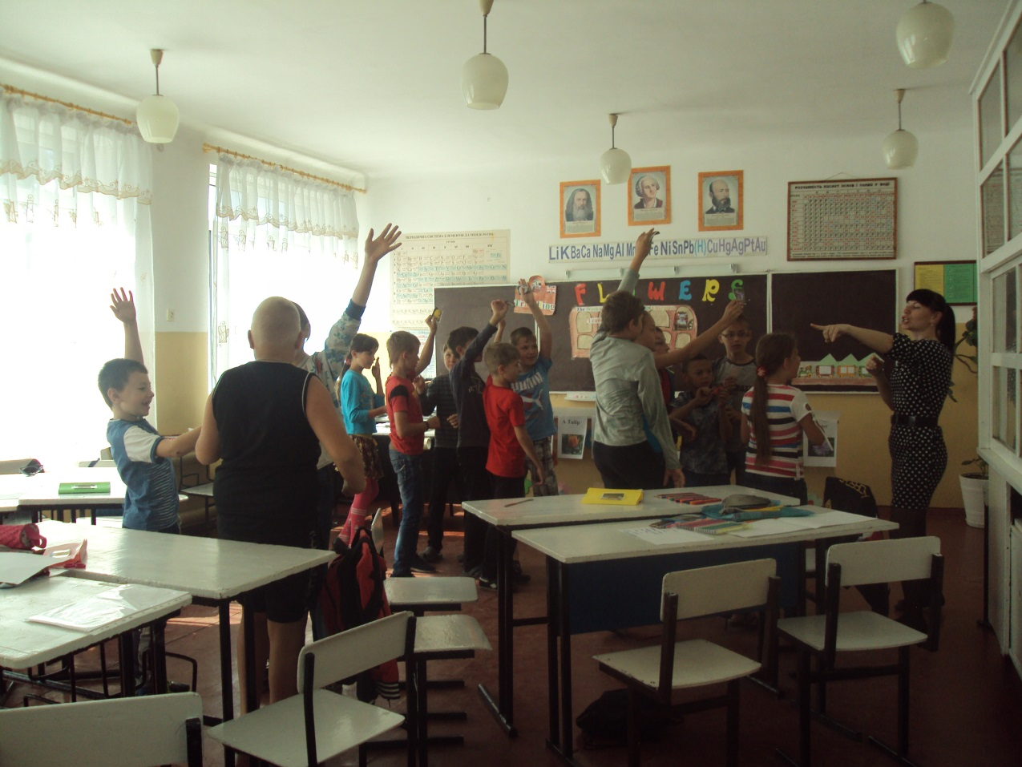

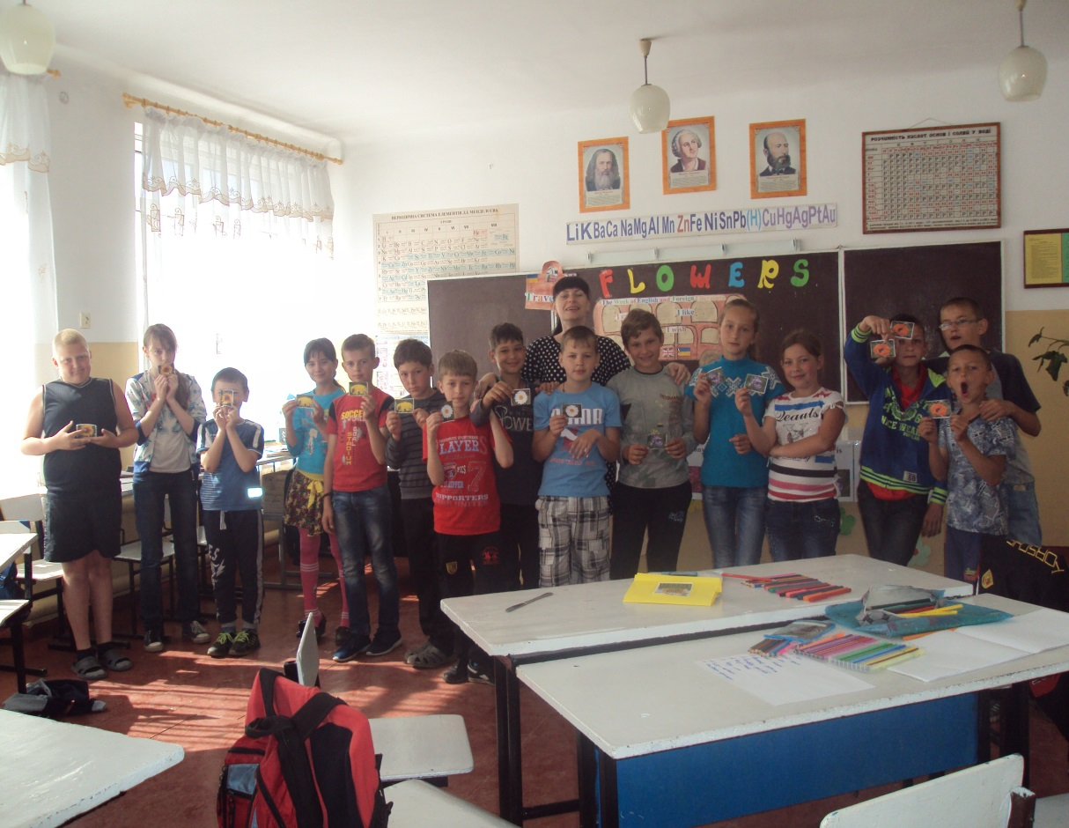

**A poppy:** Excellent! You have showed us that you can run very fast and name the flowers in English.

**A rose:** You can run very well and fast, but can you read poems in English well and fast? Let’s check it up. Each team has a poem about roses. I give you 5 minutes for preparing your reading. Start!

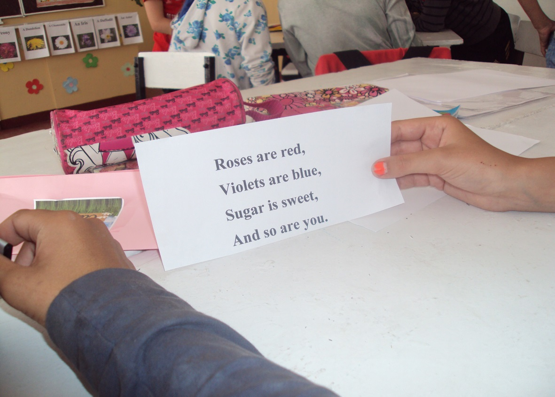

**A poppy:** As for me I liked reading of each team. What do you think about your reading?

**A rose:** I think you know the home of flowers. So what is it? Yes, you are. It’s a flowerbed.

Look at it. What flower do you like? Start like this: I like…

**A poppy:** Now you should travel around this flowerbed. Someone from the team will take a card and read the name of the flower. Then another one should jump on that flower. Everyone can try. Good luck!

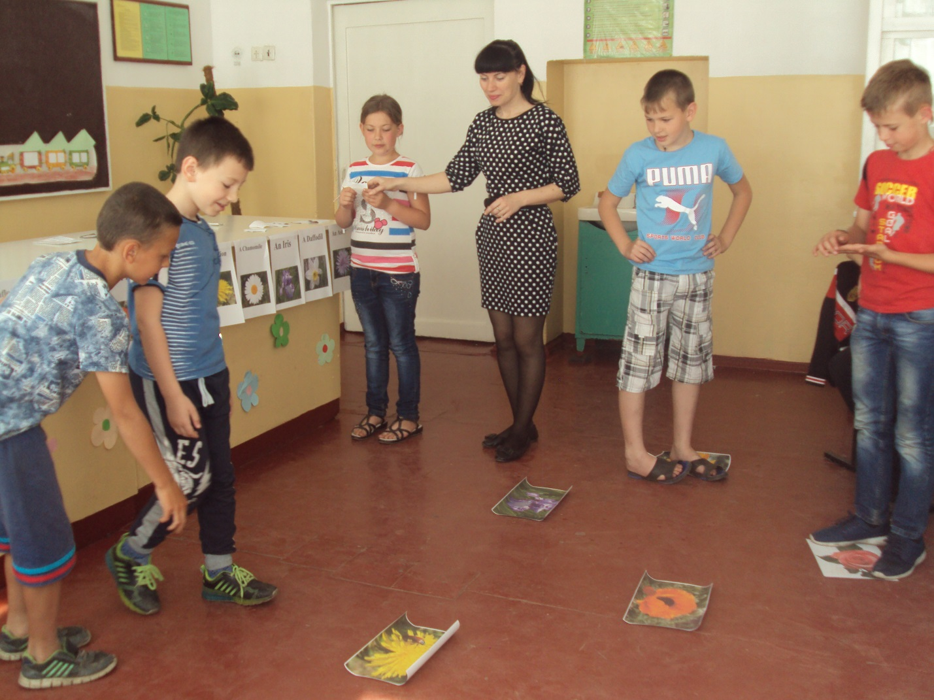

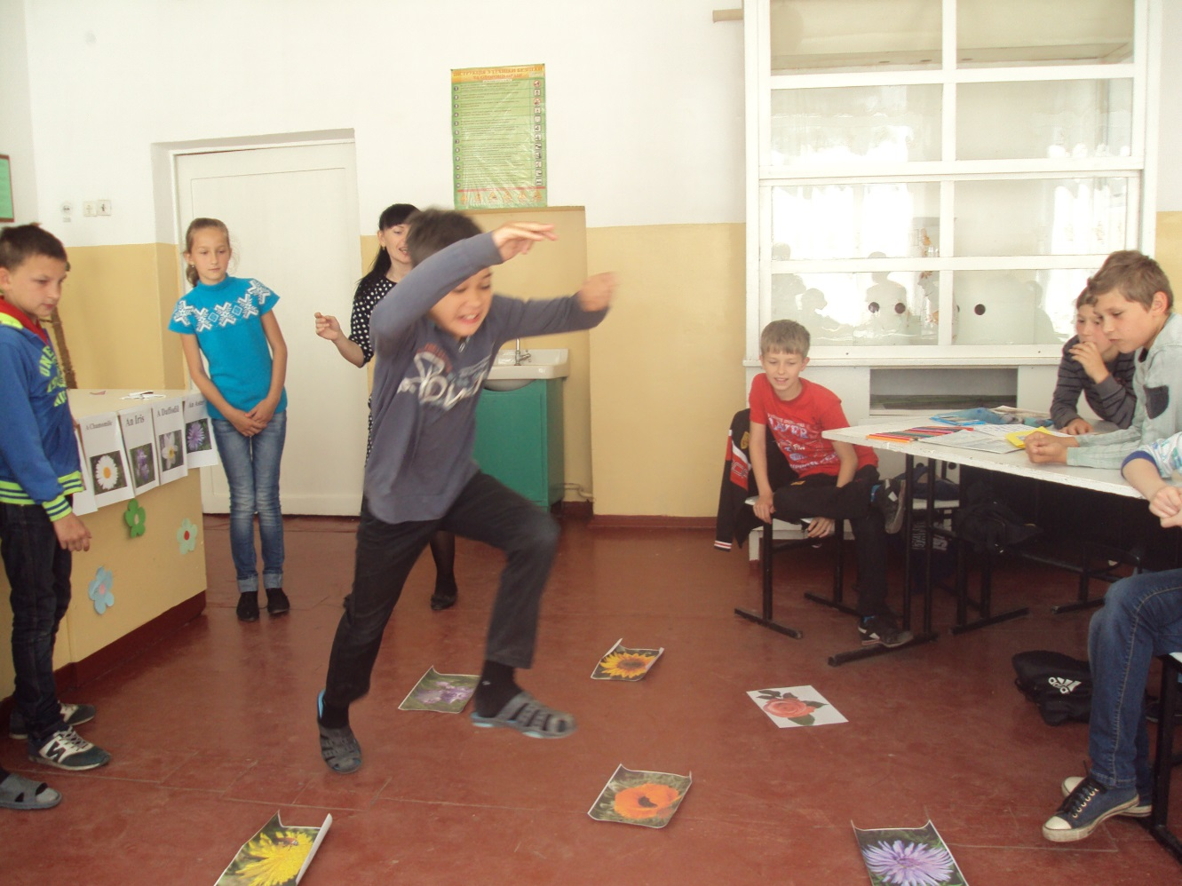

**A rose:** You are all good jumpers! How about projects? Let’s make a beautiful picture of the flowers. You have a nice chance to be painters!

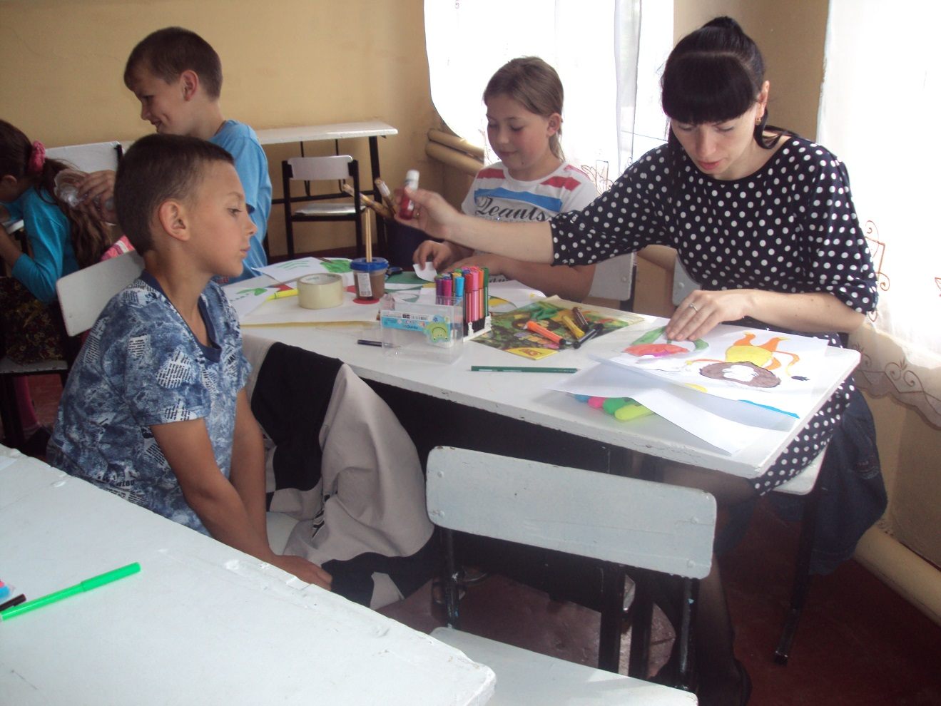

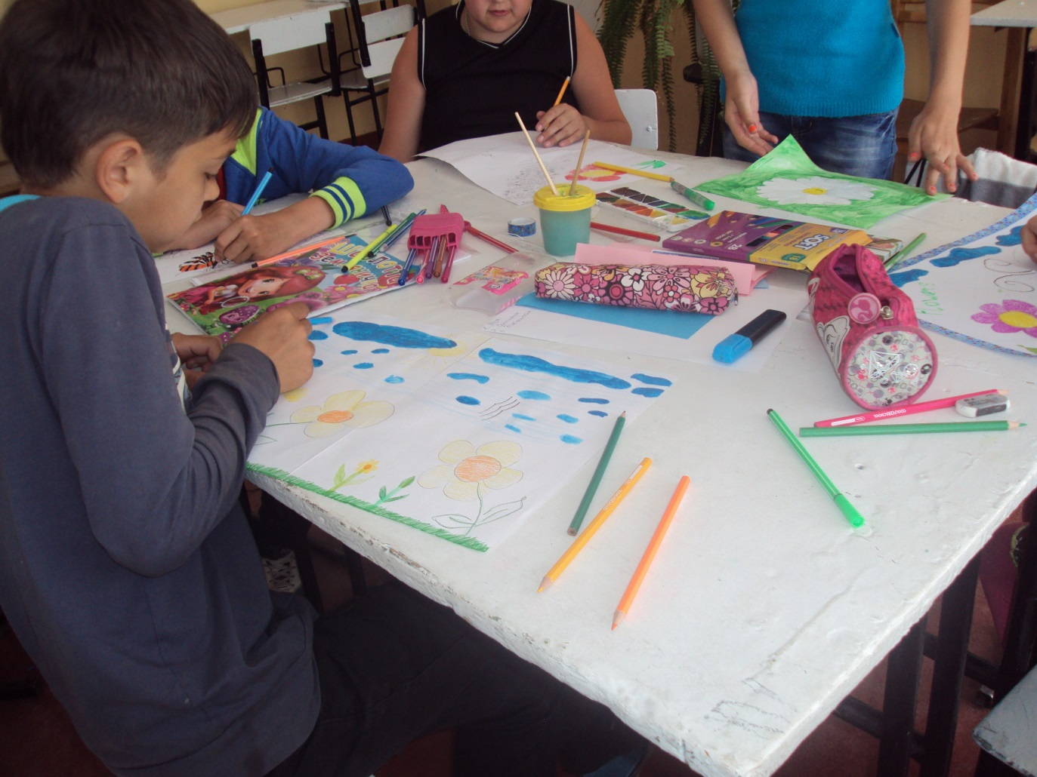

**A poppy:** Are you ready? Let’s watch your projects.

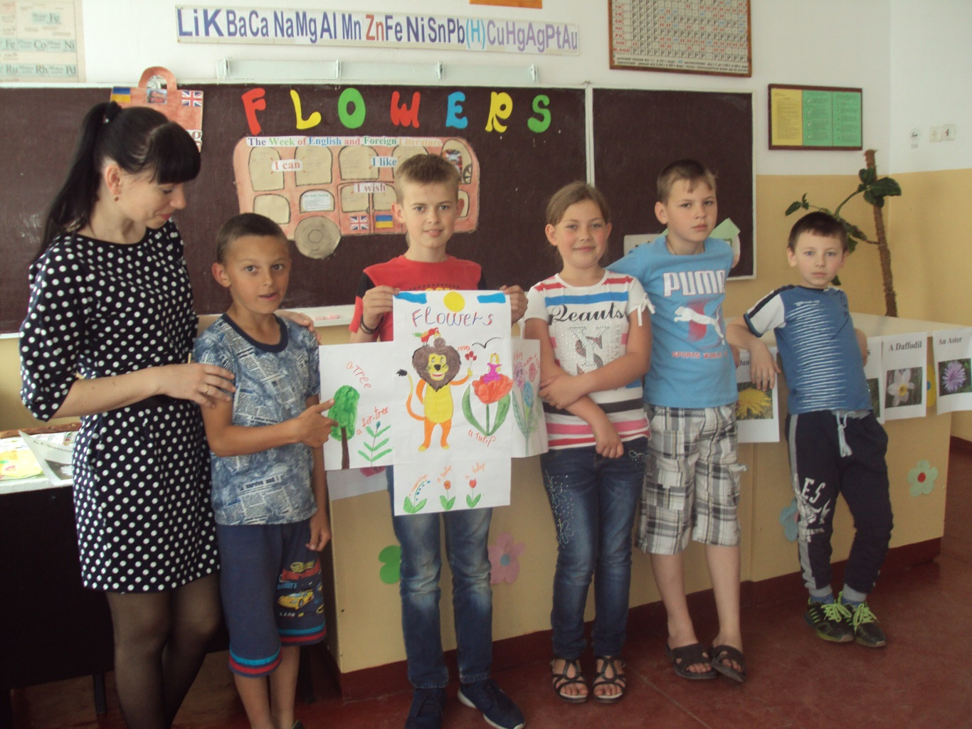

**A rose:** Dear boys and girls, thank you for your nice work and good emotions. What do you like best of all? I hope you really enjoyed the time. I hope you will remember the names of flowers in English. I wish you good luck! Good bye!

