**One Day in a Camp**

**Theme: “Ukrainian Cuisine”**

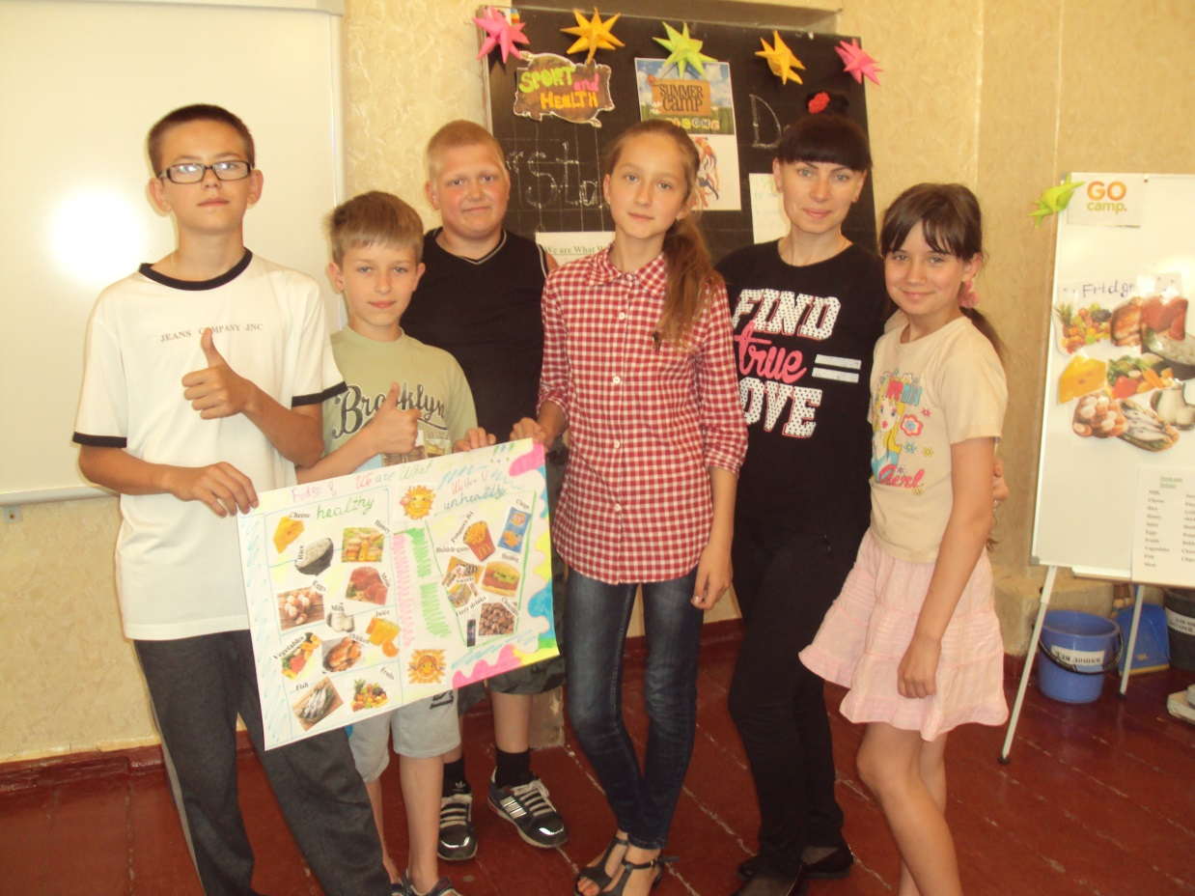

**Hrodivska school**

**Pokrovsk district**

**Teacher - Horbunova**

**Svitlana Oleksandrivna**

**2017**

**Theme: “Ukrainian Cuisine”**

**Objectives**: to learn new words; to respect Ukrainian culture and food; to develop skills in reading, writing, speaking and listening in English; to cooperate with teammates; to discover new facts about yourselves.

**Details**: chairs, desks, a projector, a smart board, cards for games, pencils, markers, posters.

**Age:** 10-12

**Time:** 8.00 – 12.00

**Type of competition**: “Master-Chef”

**Procedure**

1. **The warming-up part.**
2. *Greeting pupils.*

Teacher: Good morning boys and girls.

Pupils: Good morning teacher.

T.: How are you?

P.: We are fine, and you?

T.: I’m fine too. Thanks. Are you ready for today’s adventures?

P.: Yes, we are.

T.: So let’s wake up together and sing our favourite song “Chica-Boom”.

(Pupils sing this song together)

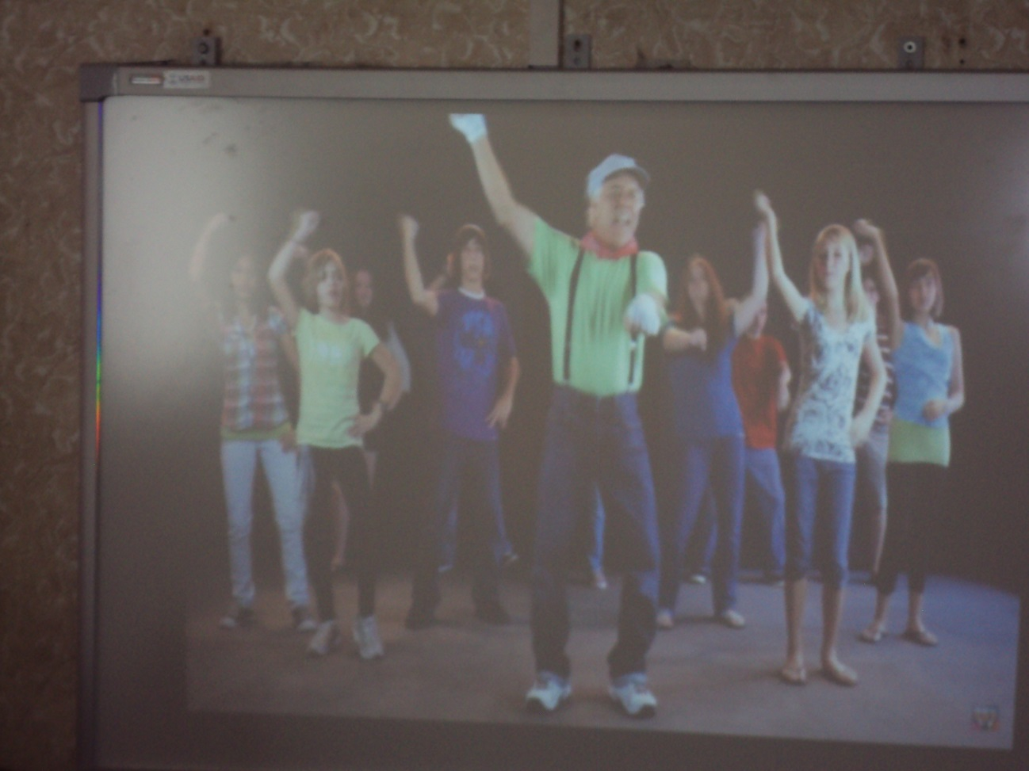

1. *Presenting a theme.*

T.: Well-done! Kids, look what I’ve got. (The teacher shows pictures with some Ukrainian dishes). Try to guess what is this?

P.: Borsch!?

T.: Great! It is right. So what do you think we’ll study today?

P.: Ukrainian dishes!

T.: Yes, super! The theme of our day is “Ukrainian Cuisine”

**2. The main part.**

T.: Children, let’s sit in a circle and play a game “The wind blows for those who…”

( The teacher sits in a circle together with children and says: “The wind blows for those who likes Borsch, and those pupils who like Borsch have to change a place with another lover of this dish.)

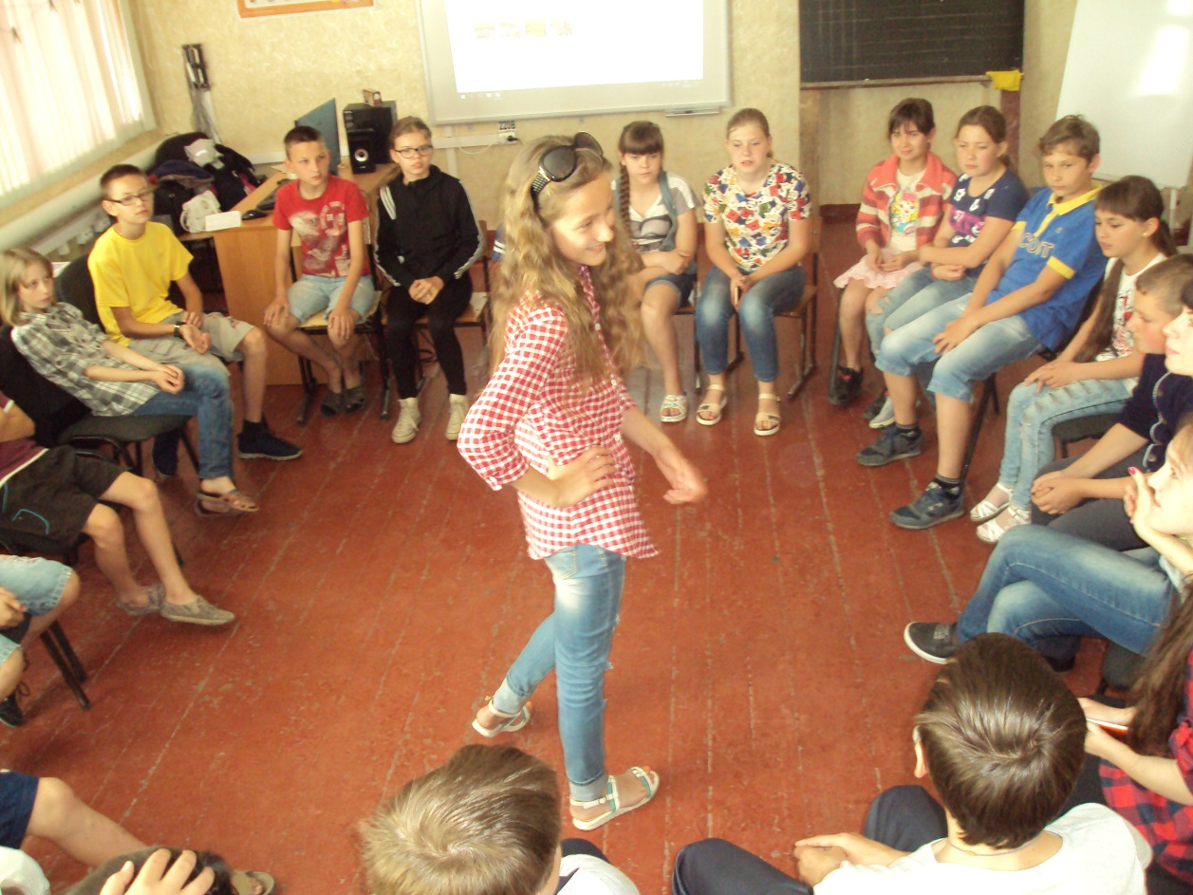

T.: It’s good. Do you like this game?

P.: Yes, we do.

T.: Now we can see what you like to eat. Let’s move on. I’d like to know some more interesting facts about all of you. I’ve got a table game “My Favourite”. You have to throw this cube and walk with a candy on the field. Then you should name something of your favourite. Is it clear?

P.: Yes, but who will start?

T.: Well, let’s count together:

Bubble-gum, bubble-gum in a dish,

How many pieces do you wish?

P.: Five.

T.: So let’s count from you and the fifth one will start.

( Pupils play a game “My Favourite”)

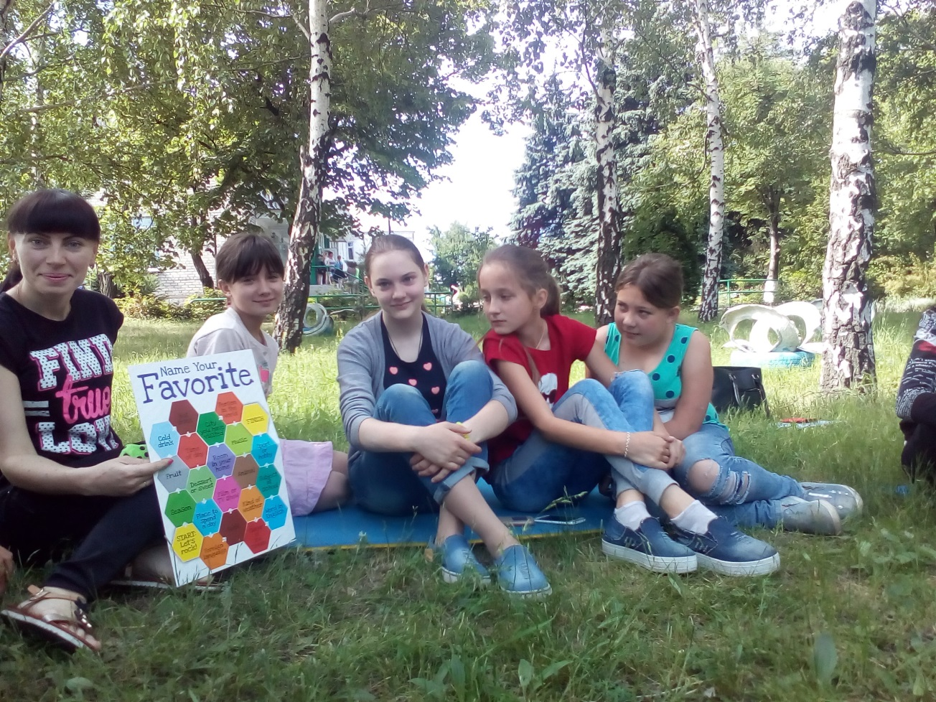

T.: O.k. How interesting that was to know each other better. Now, please, find a sticker on your chair.

( Pupils look under their chairs and find stickers.)

T.: Children make teams according to the colour of your sticker.

( Pupils make teams and sit at the desks.)

T.: So, we have three teams today: red, green and yellow. It is just like in Master-Chef. So, welcome to the show Master-Chef!

P.: What about our tasks?

T.: Each team should create a name of the restaurant and menu with the first and the second course and dessert. There are 6 people in each team, so one couple is responsible for the first course and so on… Do you understand?

P.: Yes, we do.

T.: Before you should start, let’s remember Ukrainian dishes, because you’ll use only our native cuisine.

(The teacher shows pictures with dishes and names them, pupils watch and repeat.)

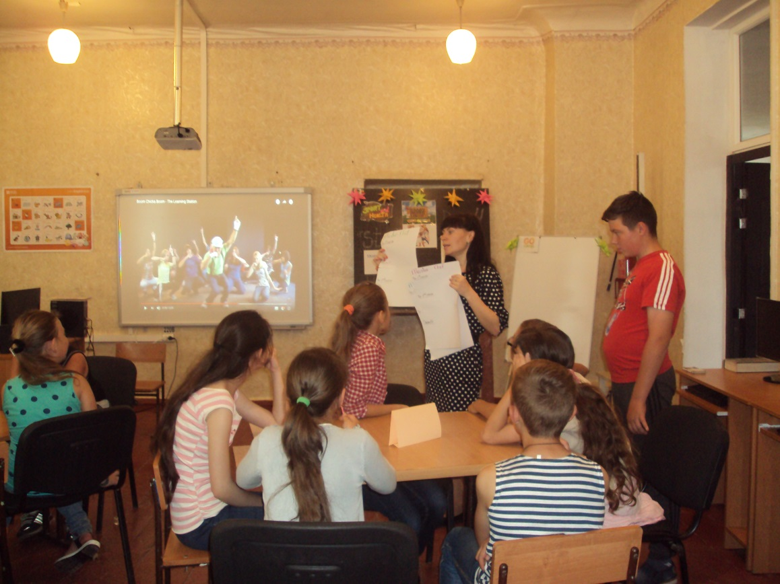

T.: Dear pupils, I wish you good luck. Start making your projects and don’t forget that after all presentations will be shown we’ll choose the best one.

( Pupils make their projects.)

**3. The final part.**

T.: O.k. Time is out. Let’s rest a little and do some exercises together.

(Children play a game “Double-Double…”)

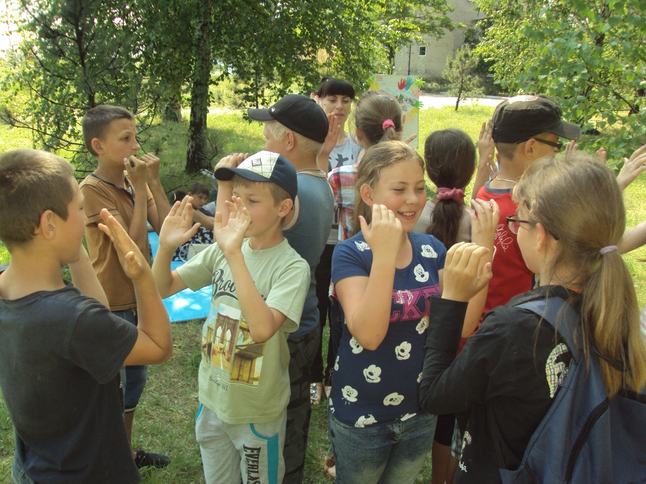

T.: So, who wants to be the first?

( One by one teams present their projects.)

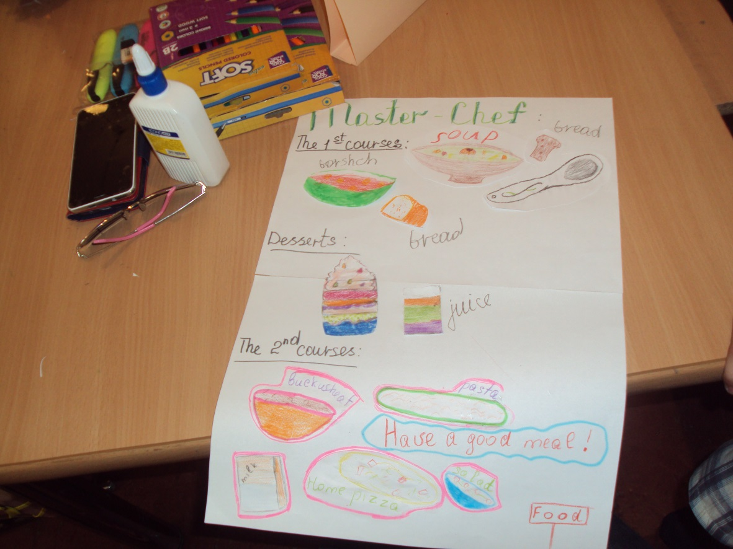

T.: Thank you all. I think, that all projects were excellent but let’s vote for the best menu!

T.: So, the winner is team… Tomorrow we’ll come to your restaurant and taste all these dishes. Let’s clap each other. Children, do you like today’s day?

P.: Yes, we do.

T.: Why?

P.: It’s interesting to watch other projects and show your own.

T.: Thank you all for today. You were the best. See you tomorrow with no less interesting adventures. Good bye!

P.: Thank you. Good bye!